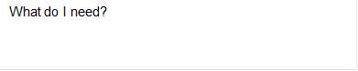

I identify with ……………………

I am living ……………………….

NHI:

Name:

Who is involved?

What happened?

I am homeless 🞏 My place is overcrowded 🞏

My place is damp 🞏 My place is cold 🞏

I am in danger of being culturally isolated 🞏

I am in danger of…………………..



When will we do this?

What are we going to do?

What do I need?

What happened?

What do I need?

What are we going to do?

When will we do this?

Who is involved?

NHI:

Name:



I am healthy. My medical conditions are……………….





Have I’ve got enough money so my need are met?



I have allergies:

What happened?

Who is involved?

When will we do this?

What are we going to do?

Is my safety compromised because of my financial situation?

What happened?

Who is involved?

When will we do this?

What are we going to do?

What do I need?

What do I need?