Purpose | To ensure that staff have the knowledge and skills to provide services in accordance with ‘Consumer Rights’ related legislation.
Scope | All name of service persons that are involved in providing services to persons using the service.
Performance Indicators | Consumer rights training will be implemented according to the services training plan.  Any adverse events involving the violation of client rights will be addressed effectively.
name of service service users receive services in accordance with consumer rights legislation.
Processes:

Employee Induction – All Staff

Within 6 weeks of employment

Team leader/manager

- Familiarisation with service users rights related policies and procedures.
- Knowledge of the Health and Disability Commissions ‘Code of Consumer Rights’.
- Knowledge about independent advocacy.

Workforce Development and Training – All Staff
Specific Training

Yearly training plan/ongoing monitoring

Team leader/manager

- If complaint/adverse event investigations indicate additional support or training in consumers rights is required this will be included in the yearly training plan.
- Any other way the need for further training/knowledge in consumer rights is identified.
- Ongoing training in consumer rights occurs as reflected in individual staff’s training plan.

Supervision/peer review –
Review of service delivery

Supervisor/supervisee/peers

- If service user’s satisfaction surveys indicate consumer rights are not consistently implemented.
- Includes observation and feed-back on implementation of consumers rights when delivering services

Purpose | To ensure that service users at name of service are supported to have an understanding of their rights.
Scope | All name of service service users and their families/whānau and other supports.
Performance Indicators | Posters, pamphlets and internet access to’ Consumer Rights’ information are facilitated by name of service and utilisation is reflected in the service users satisfaction surveys.
Service users are informed of their rights.
Processes:

Service user orientation/induction

During the service entry processes

First contact staff

- Service users will receive written information that includes ‘Consumers’ Rights’ and ‘Independent Advocacy’.
- The information is discussed with the service user.
- The audio ‘Health and Disability Commission, Code of Consumer Rights’ is made available to service users in their preferred language
- The ‘Code’ is made available in sign language.
- Provide advocacy information for specific needs.
- Provide access to advocates.

Ongoing Provision of Information

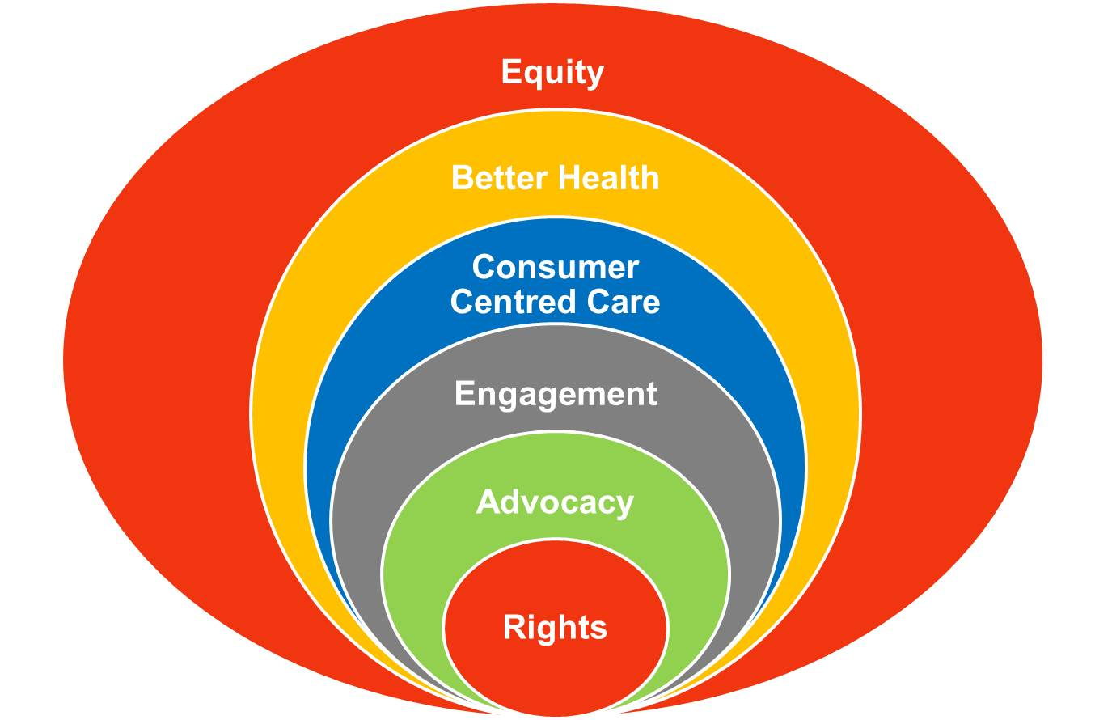
Throughout service delivery

Service users and staff

The ‘rights’ are discussed with service users when:
- They have made a complaint.
- Service delivery is reviewed.
- Treatment options are discussed.
- During service users meetings.
- When requested by the service user or their family/whānau/supports.
- Some service users will have access to a computer and the internet including information on ‘Consumers’ Rights’ and on
Health Advocacy Services .

Consultation

Group/Role | Date

