Purpose | To provide a framework that supports a diverse workforce and equal employment opportunities.
Scope | name of service employees, Board of Trustee’s/Director(s) and contractors.
Policy | name of service is committed to meeting its responsibilities under the Treaty of Waitangi and to the principle and practice of equity. Non- discriminatory practices will inform the following processes:  - When recruiting and selecting employees.  - Setting terms, conditions and benefits offered as part of employment.  - Determining who receives training and what sort of training is offered.  - Deciding who is considered and selected for transfer, promotion, retrenchment or dismissal.  Discrimination for the following reasons will not be tolerated:  - sexual orientation  - ethnic or national origins  - disability  - age  - political opinion  - employment status  - family status  - gender identity  - marital status  - religious belief  - ethical belief  - race
References
Legislation | Health and Safety at Work Act 2015  Human Rights Act 1993  New Zealand Bill of Rights Act 1990  Employment Relations Act 2000  Equal Pay Act 1972
Guidelines  and  Standards | Diversity Works NZ  Employer Support  Human Right’s Commission resources  NZS 8200:2015 Rainbow-inclusive workplaces: A standard for gender and sexual diversity in employment  Tracking equality at work, national equal opportunity network

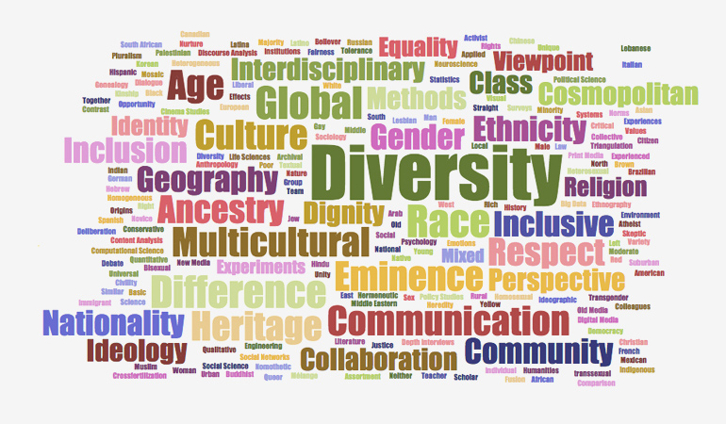

Promote and apply diversity in the workplace

At all times

All name of service employees
Board members/Directors and contractors

Balance work and life

Pregnancy and breast feeding

Engage all ages at work

Employment for disabled people
Be disability confident

Harassment at work
Language in the workplace
Value Culture in the Workplace

Sexual orientation and gender identity
Religious diversity

Trans people and employment

Workplace bullying
Bullying prevention toolbox

Pay equity

Consultation
Group/Role | Date

