|  |  |
| --- | --- |
| **Purpose** | To ensure that visitors are welcome at the service and that visits are safe for service users and their visitors. |
| **Scope** | All premises/homes/residences and all visits. |

Service users have the right to have visitors

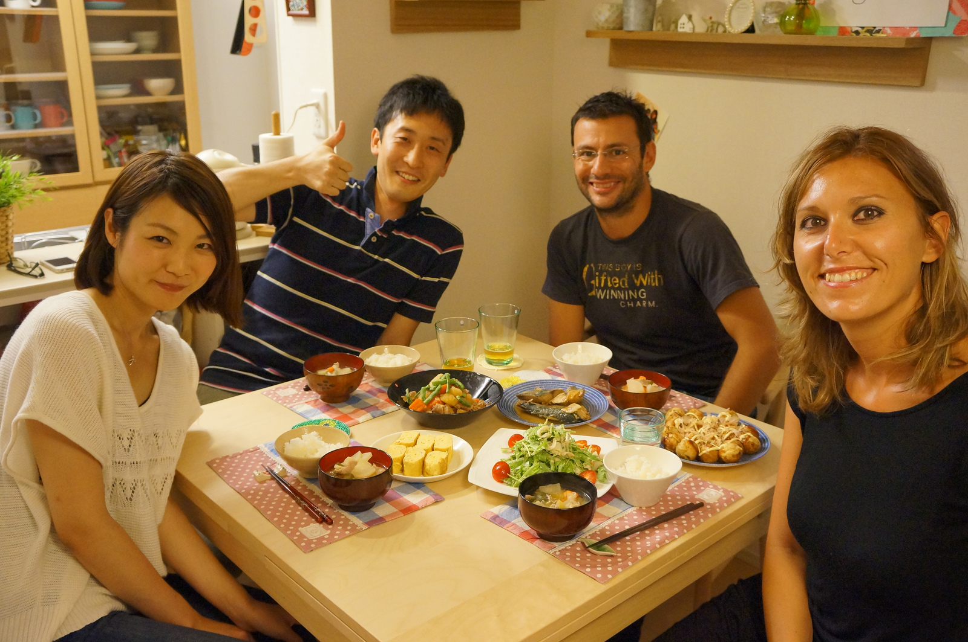

Keeping in contact with family/whānau and friends

Between the hours of 0800 and 2000 or as negotiated with staff.

Visitors are required to complete the visitor’s book on arrival and when leaving the premises. This is important in case of an emergency or evacuation.

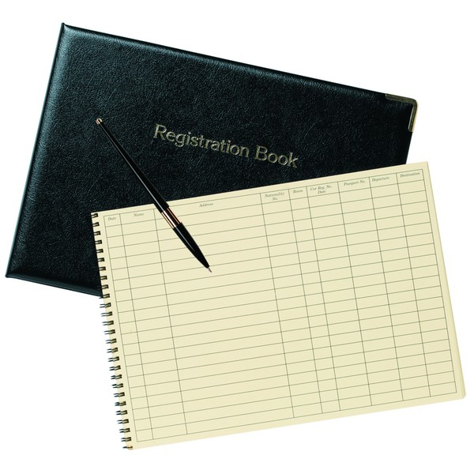

Children and young people are welcome to visit. They need to be accompanied by an adult who is responsible for their safety and care.

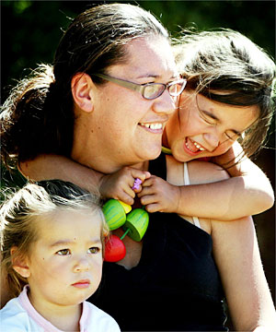

We cannot offer accommodation. Staff will be able to provide you with information about accommodation close-by.

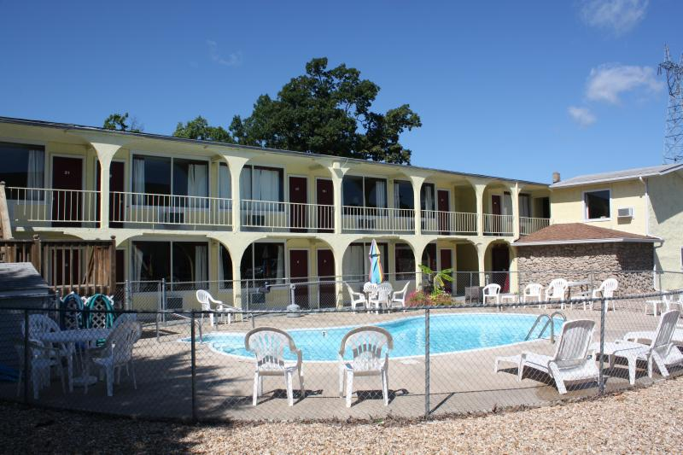

**Measures that make visits safe**

**As circumstances require**

**Staff and on-call staff/service users**

Visitors will be asked to leave in the following situations if:

* They have influenza.
* They enter bedrooms of service users they are not visiting.
* They are threatening or intimidating.
* They give or deal tobacco/alcohol or other substances.
* They are intoxicated with alcohol or other drugs.
* There are legal processes in place such as trespass orders, non-association order and/or protection order.
* They carry weapons.

The service will call the police if the safety of service users or staff are compromised and the visitor refuses to leave.

**Safety**



Visitors who behave in an unsafe manner will need to pre-arrange their future visits in advance to allow time for extra safety measures to be put in place. The service may arrange the following for such visits:

* Supervised visits.
* Visits have to occur in a specified room.
* Staff and service users will be alerted of some visits.

* Visitors are not to take photos or videos of service users, except the person they visit (with that person’s permission).
* The service requests that visitors respect the confidentiality of service users and not reveal their identity to other persons or on a social website.
* The service will arrange visits in a private space if notice of this requirement is given in advance.

**Confidentiality**

.

.







# Consultation

|  |  |
| --- | --- |
| **Group/Role** | **Date** |
|  |  |
|  |  |
|  |  |
|  |  |