Purpose |  | To ensure that we operate internal procedures to detect and prevent theft and fraudulent actions.
Scope |  | This document relates to fraud and theft that is committed by current and former workers, contractors, volunteers, management, or our Board members.
References
Information |  | Controller and Auditor General: Good practice  Serious Fraud Office Guidance
Legislation |  | Theft (Crimes Act 1961, s 219)  Fraud (Crimes Act 1961, s 220, 228, 240)
Organisational documents |  | Asset Management  Credit Card Policy and Procedure  Quality and Risk  Sensitive Expenditure  Whistleblowing/Protected Disclosure Policy and Procedure
Fraud - definition |  | Is an intentional act by one or more individuals involving the use of deception to obtain an unjust or illegal advantage. (Controller and Auditor General)
Theft - definition |  | ‘Theft as a servant’ involves an employee (worker), or person in a position of trust, dishonestly taking or using their employer's property, money, or resources for personal gain.
Common types of fraud and theft |  | - theft of cash;  - theft of equipment;  - theft of inventory;  - theft of intellectual property;  - fraudulent expense claims;  - fraudulent misuse of a credit/debit card;  - fraudulent misuse of our bank accounts;  - false invoicing;  - payroll fraud;  - privacy breaches;
Prevention
Understanding theft and fraud
Understanding what drives theft and fraud are key to counter such actions.
Pressure, opportunity and rationalisation increase the risk of fraud occurring. Identifying when these factors are present is key to creating effective countermeasures.
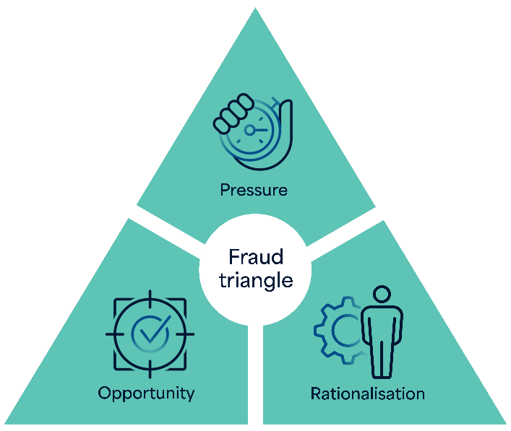

- Pressure: The motivation for people to commit theft and fraud. These pressures might be personal, financial or work-related.
- Opportunity: A gap or weakness in our system that can be exploited.
- Rationalisation: Individuals justify their theft and fraudulent behaviour, convincing themselves it is acceptable or deserved.
Our frameworks to minimise fraud and theft
- Role completes a fraud risk assessment.
- Our financial systems are designed to prevent and detect fraud and theft.
- We meet the requirements and standards of generally accepted accounting practices.
- We keep secure and account for our physical and financial resources.
- Workers and managers with delegated responsibility for ensuring the safety of physical and financial resources are competent to carry out and are held accountable for the proper execution of these responsibilities.
- Managers/board members understand their responsibilities for preventing and detecting the risk of fraud and theft.
- Policies that clearly identify the required processes and safety measures (refer to References: Organisational Documents).
- We implement a proactive approach to preventing fraud and theft through monitoring activities.
- People who work or provide a service for us understand their responsibilities for preventing and detecting the risks of fraud and theft. They are familiar with our Whistleblowing/Protected Disclosure Policy and Procedure.
- We have a policy on accepting gifts or services (refer to My Rights/Abuse and Neglect, Boundaries and Conflict of Interest).
- We screen new employees, including criminal history checks.
- We review fraud and theft controls regularly at least annually.
- We communicate this policy regularly at least annually.
- We have a culture where workers are willing to raise any concerns that they may have regarding fraud and theft and know that their concerns will be taken seriously and that they would not suffer any retaliation.
- Our role is responsible for ensuring the above processes are in place, implemented and monitored.
Monitoring activities
We enable and routinely monitor 3-monthly:
- workers’, managers’, contractors’, board members’ expenses;
- credit/debit card expenditure;
- our bank accounts;
- conflicts of interest;
- ongoing criminal history checks – 2-yearly
- when fraud or corruption risks are raised, we take proactive steps to reduce the risk.
 | - Any statement made on behalf of our organisation and related to any instance of supposed or actual theft and fraud shall be made exclusively by role.  - All matters related to the case shall remain strictly confidential and breaches will be dealt with through disciplinary processes.  - Any investigation into theft or fraud allegations will be conducted in a manner that conforms to the principles of natural justice and follows fair and just processes.

Allegation of theft or fraud
Responsibility for the overall processes: role
Step 1 | Anyone can report | The allegation is reported to the role and the Chair of our Board who report a serious matter to the New Zealand Police or if it is serious and/or complex fraud to the Serious Fraud Office.  The Health Integrity Line can also be contacted 24/7 to report fraud.
Step 1 | As soon as the theft or fraud is suspected or discovered
Step 1 | As soon as the theft or fraud is suspected or discovered | Examples of serious allegations of theft or fraud:  - Buying a company car for private use.  - Buying a house from our organisation for less that it is valued.  - Creating fake accounts to pay company money into.  - Creating fake invoices.  - Private overseas trip paid for with our organisation’s money.  - Changing car ownership from company to private one.  - Selling the organisation’s intellectual property.  - Receiving money for privacy breaches.
Step 1 | As soon as the theft or fraud is suspected or discovered | Less serious allegations are reported to the role or the Chair of our Board.
Step 1 | As soon as the theft or fraud is suspected or discovered | Examples of less serious allegations of theft or fraud:  - Using the company car to travel less than 50km for private travel.  - Paying for a private lunch with the organisation’s debit/credit card.  - Stealing cash – under thousand dollars - from petty cash.  - Doing private grocery shopping using the organisations bank account, credit/debit card or cash.  - Taking items that were purchased to be used by tāngata whaiora/tāngata whaikaha such as: TV, bedding, computer, food or heater.
Step 2 | role | - Record the details of the allegation - the person(s) allegedly involved; the nature, time and circumstances and the quantity and/ or value of the theft or fraud if known.  - Request a written statement from the person who informed the role or the Chair of our Board of the alleged fraud/ theft.  - Appoint an investigator.
Step 2 | Within 24 hours of the allegation
Step 3 | role | - Take initial action to prevent suspected or actual fraud and/or theft.  - Liaise with the Serious Fraud Office or Police if serious fraud or theft is suspected or has occurred.  - Consult with the person who reported.  - Confidential consultation with senior management/governance group about the allegation and how to manage it.  - Decide and document the investigation process.
Within 5 days
of the allegation

Step 4 | role | - Make sure the person alleged of theft/fraud has no longer any means to continue fraudulent behaviour or is able to commit theft. For example, change passwords, confiscate keys, freeze accounts, tress pass, prevent access to computers and emails etc.  - Inform the person alleged of the theft and/or fraud in writing of the allegation that has been received and request a meeting with them and their representative(s).  - Meet with the person (and representatives) to explain the allegation against them.  - Obtain a written response.  - In some situations, the alleged person might need to be suspended.  - Any verbal response must be recorded as minutes of that meeting and the accuracy attested by all persons present.  - Advise the alleged person in writing of the processes to be involved from this point on.
Within 7 days
of the allegation

Step 5 | role | Dependent on the seriousness of the fraud or theft and the information and evidence obtained thus far indicating that fraud and theft might have occurred:  - Invoke any disciplinary processes in line with the employment/contractor contract.  - Lay a complaint with the New Zealand Police or the Serious Fraud Office.  - Contact The Health Integrity Line.  - Commission an independent expert investigator in case of fraud.  - Seek legal advice.  - Advise our funding agencies of the situation.
Step 5 | Within 15 days  of the allegation
 | If no prima facie case (sufficient evidence exists to support a case) exists, document this decision and record that no further action is to be taken.

