Purpose | This process is documented to ensure that  - service users and their families/whānau are informed about the services they are referred to,  - access is in line with contractual obligations,  - access processes are consistent, and facilitate a service user friendly and safe entry to the service.  - service access processes are based on service user not services needs.
Scope | The services’ referrers and people and their family/whānau considered to be or have been referred.
References
Contracts/  agreements | Tier One, Two and Three Service Specifications
Organisational policies/  procedures | Consent to Receive Services.
Tier One Mental Health and Addictions Service Specifications Requirements:
- All providers need to ensure information about services is available and easily accessible to Service Users and their family and whānau.
- Service Users should be informed of their choices and options for care.

Manager/CEO/Board
Service Information

Examples of participants in developing service information:
- service users
- potential referrers
- cultural advisors
- service users family/whānau

Information about the service will be distributed to:
- Potential referrers.
- The public through the organisations website.
- Health services and social agencies through service brochures.
Information should at least include Te Reo and any other language that reflects the service user group.

Referral conditions
Referrer/name of service

Eligibility
Referral Methods
Referral Sources

Options:
- In writing.
- Using the service referral template on-line.
- Face to face meeting with person considered to be referred and referrer.

- Eligible for a public funded health service.
- Age group:
- Service user agrees to the referral.
- People with an identifiable or suspected mental health disorder and/or substance use issue.

Your tier three service specification identified who can refer to your service.

Please enter your requirements here.

Referral responses

Within 1 week or earlier

name of service/title of role referred person/referrer

Acknowledge the referral
Discuss with the referrer and person referred:
- The service being able to meet referred person specific needs.
- Referred person has sufficient service information to provide consent for engaging.
- Invitation to visit/meet name of service (housing, support worker, key worker)

Services declined

Services accepted
- Provide information pack to service user and to family/whānau and other supports as required.
- Arrange time for service entry.
- Invite family/whānau and other supports.
- Request relevant information from referrer.
- Inform referrer and person referred of the reason for decline.
- Suggest more appropriate services that could meet the referred person’s needs.
- Inquire why referred person declined.
- Complete the declined services record.

Prioritisation

Referrer/name of service/referred person

When the demand for services exceeds the availability the following prioritisation criteria will be considered:
- Urgency to address needs.
- Impact the mental illness/addiction has on the individual and their family/whānau/supports.
- Relevant legal requirements (MH Act, Alcoholism and Drug Addiction Act).
- Safety issues (pregnancy, risks to self and/or others).
- Lack of support.
- Transition from youth to adult services.

For your service specific details refer to your tier three service specification or a variation to your agreement.

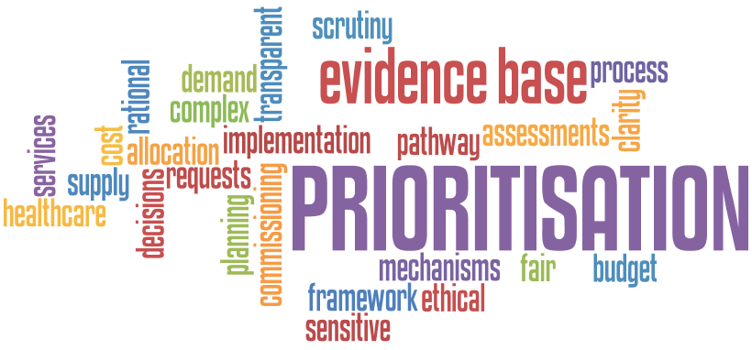

Consultation
Group/Role | Date

