|  |  |
| --- | --- |
| **Purpose** | People that are at the services premises receive an appropriate and timely response during emergency and security situations. |
| **Scope** | Service users, staff, visitors, contractors and all premises the organisation operates in or from. |
| **Links** | [Auckland Civil Defence](http://www.aucklandcivildefence.org.nz/)  [Ministry of Civil Defence and Emergency Management](http://www.civildefence.govt.nz/get-ready/)  [WorkSafe Emergency Procedures](http://www.worksafe.govt.nz/worksafe/information-guidance/all-guidance-items/emergency-procedures) |

**EMERGENCY CONTACT: 111**

|  |
| --- |
| [Emergency status for the Auckland Region](http://www.aucklandcivildefence.org.nz/)  [Emergency status for the Northland Region](http://www.nrc.govt.nz/civildefence/) |
| radio%20icon%20small **Auckland region radio station frequencies:** |
| [In an emergency the radio is your prime source of information](http://www.radionz.co.nz/emergency):  [Frequency Finder](http://www.frequencyfinder.co.nz/)  Print the frequencies of your area. |

**Fire safety and evacuations**

**The service implements an** [**evacuation scheme**](https://onlineservices.fire.org.nz/home/evacuationschemes)**.**

**Manager**

**Fire and Emergency Training**

**Service users**

**Visitors**

**Staff**

* Information pack includes fire safety and emergency processes.
* Participation in evacuations.
* Civil defence resources for [people with disabilities](http://www.getthru.govt.nz/how-to-get-ready/people-with-disabilities/)
* [Read and download resources.](http://getthru.govt.nz/downloads)
* Emergency exits to be shown.

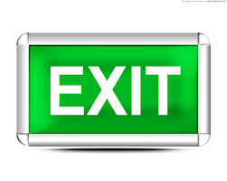

* At orientation.
* 6 monthly evacuations.
* A staff member that holds a first aid certificate is present 24/7 where housing services are provided.
* [Read and download resources.](http://getthru.govt.nz/downloads)

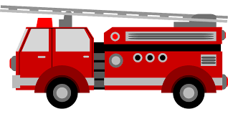

**Fire safety and emergency maintenance activities**

**Health and Safety Officer**

**Fire Extinguisher:**

* In kitchen (& fire blanket)
* bed room areas
* strategic placements

Ensure yearly maintenance checks of the equipment.

**Knowing who is on site:**

* Visitor book to be completed.
* In-and out board to be maintained by service users and staff.

**Smoke Alarms:**

* bed rooms
* kitchen
* offices
* lounge
* activity rooms

Batteries to be changed 6 monthly.

**Responsibility for evacuation:**

* a staff is allocated the responsibility for evacuation processes
* when evacuating, the staff member will wear an orange west

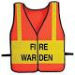

**Information:**

* Fire safety and evacuation flowcharts & floor plans are displayed in each client room, kitchen and office and communal rooms.

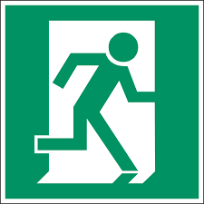

**Smoke Alarms:**

* Are monitored 6-monthly.
* Gives siren sound when activated.
* Show the alarm that is activated or
* show a red light on activated smoke alarm.



**Emergency equipment**

**Health and safety officer**

**Governance/manager**

**Other contingencies**

**M**

**O**

**N**

**T**

**H**

**L**

**Y**

**C**

**H**

**E**

**C**

**K**

**S**

**Alternative utilities**

[**First aid kit**](http://www.civildefence.govt.nz/memwebsite.nsf/Files/Consistent-messages-feedback/$file/Part%20A%20first%20aid%20final.pdf)

[**First aid guidelines**](https://www.redcross.org.nz/yk-files/b29e18e0b30b99580fc109aa1ad5896f/first-aid-2009.pdf)

* Move to alternative premises.
* Move perishable food to other premises.
* Collaborate and coordinate with other service providers.

**Electricity:**

* solar or manual energy torches
* generator
* solar or wind energy

**Located:**

**Computers:**

* have a back-up laptop
* have charger batteries full at all times

**For cooking:**

* barbeque
* gas cooker
* camping stove

[**Civil defence emergency kit**](http://www.civildefence.govt.nz/memwebsite.nsf/Files/Public%20Education%20Toolbox/$file/NCCSampleCDKit.pdf)

**Located:**

**Telephones:**

* Ensure mobile batteries are ¾ full at all times.



[**Personal protective equipment**](http://www.dol.govt.nz/infozone/businessessentials/safety/hazards/ppe.asp)

**Located:**

**Cars:**

* keep petrol/diesel 2/3 full at all times

**Specific emergency situations**

**Flip-charts on emergencies will be located at strategic placed areas**

The organisation subscribes to the [civil defence alerts](http://www.aucklandcivildefence.org.nz/emergency-status/subscribe-to-emergency-updates/)

Consider downloading the [Red Cross Hazard APP](http://www.aucklandcivildefence.org.nz/alerting/)

[**Severe weather**](http://www.aucklandcouncil.govt.nz/EN/environmentwaste/naturalhazardsemergencies/hazards/Pages/tropicalcyclonehazards.aspx)

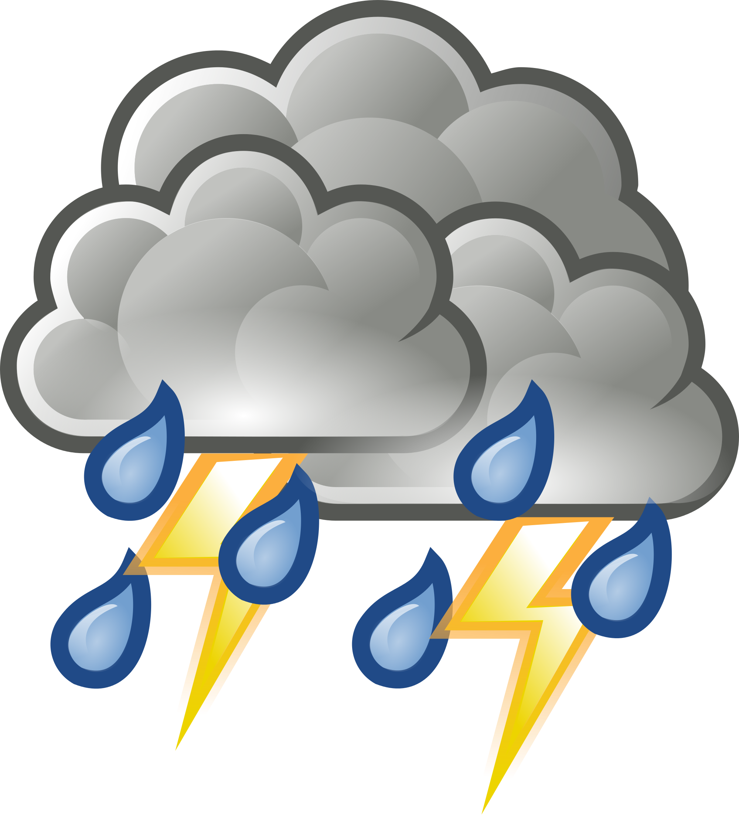

**[Fire](http://www.aucklandcivildefence.org.nz/hazards/natural-hazards/" \l "Fire)**

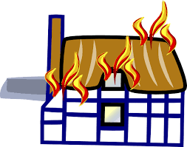

**[Flood](http://www.aucklandcivildefence.org.nz/hazards/natural-hazards/" \l "Flooding)**



[**Landslide**](http://www.aucklandcouncil.govt.nz/EN/environmentwaste/naturalhazardsemergencies/hazards/Pages/landinstabilityhazards.aspx)



**[Tsunami](http://www.aucklandcivildefence.org.nz/hazards/natural-hazards/" \l "Tsunami)**



**[Eruption](http://www.aucklandcivildefence.org.nz/hazards/natural-hazards/)**

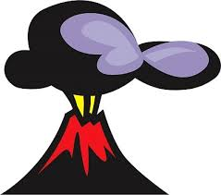

[**Pandemic**](http://www.health.govt.nz/our-work/emergency-management/pandemic-planning-and-response)



**[Earthquake](http://www.aucklandcivildefence.org.nz/hazards/natural-hazards/" \l "Earthquakes)**



[**Aggression**](http://communitylaw.org.nz/community-law-manual/chapter-29-harassment-and-bullying/harassment-in-the-community-getting-protection-under-the-harassment-act-chapter-29/)

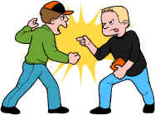

[**Gas leak**](http://www.med.govt.nz/energysafety/consumer/safe-living-with-gas-lpg/gas-leaks)



[**Bomb threat**](http://www.police.govt.nz/advice/businesses-and-organisations/suspicious-mail-bomb-threats)

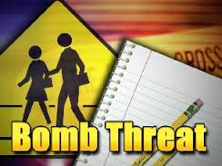

**[Armed hold-up/robbery](https://www.police.govt.nz/safety/business-crime-prevention.pdf)**

**[Witness form](https://www.police.govt.nz/safety/business-crime-prevention.pdf)**



[**Hazardous material**](http://www.worksafe.govt.nz/worksafe/information-guidance/guidance-by-industry/hsno)

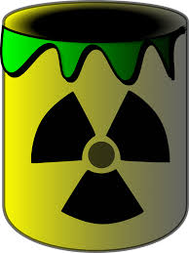

**SECURITY**

**Buildings**

**On-Call System**

**Staff on duty**

**Manager**

* Unoccupied premises will be locked.
* Before leaving the premises
  + lock the windows
  + turn off electric equipment and gas
  + activate the alarm.
* Only staff will have access to the keys for the premises and individual rooms.
* Keys are not to be given to family members.
* A person is on call 24/7.
* The on-call roster is documented and accessible in the office and/or intranet.
* Never hesitate to call on-call staff.
* On-call staff will escalate the call in cases of a major adverse event such as:

* high risk situations
* staffing issues
* natural disaster
* human made disaster

**Activities off-site**

**Staff on duty**

Staff on business related activities will implement the following:

**Actions**

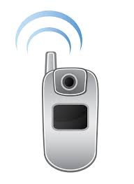

**Communication**



**Documentation**



* If the return is delayed inform the person in charge at the service.
* As soon as you return inform the person in charge of your return.
* A mobile phone is always taken.
* The person in charge will call the staff member if not returned within 30 minutes of the anticipated time.
* If the staff member cannot be contacted, discuss with the manager/on-call staff what actions need to be taken.

In the service diary:

* destination
* expected return
* phone contact
* name of all the people going out
* document the time of return and sign off

* Report to the on-call manager and clinical DHB team if a service user has gone missing.

**Before you transport service users – refer to the ‘Use of Company Vehicles’ policies and procedures.**

# Consultation

|  |  |
| --- | --- |
| Group/Role | Date |
|  |  |
|  |  |
|  |  |
|  |  |