Purpose | Service users, staff and people spending time at the organisations facilities are provided with a suitable and accessible physical environment. All facilities are fit for their purpose.
Scope | All buildings services are provided in or from.
References
Legislation | Electricity (Safety) Regulations 2010 – sect 26  NZS 8134:2008 Health and Disability Services Standards  The Building Act 2004
Guidelines | Auckland City Council Consents  Bathroom and Toilet Hygiene in the Home  Building Warrant of Fitness  Energy safety  Guide to hot water cylinder temperatures
Name of service policies/  procedures | Asset Management  Health and Safety Manual  Smoke free Environment  Emergency and Security Systems

Buildings and Property
The service will comply with the relevant building codes and requirements.
It will maintain a Building Warrant of Fitness (BOF) or provide evidence that a BOF is not required.
Safety

Manager/CEO & staff

Building requirements
Equipment

- All equipment will be purchased from reliable sources.
- Only registered trades people will install/repair equipment.
- Service users will have orientation to equipment they will be using.
- Staff will be oriented to all equipment during their induction process.
- Equipment will be calibrated in line with the maintenance log.
- Required adjustments will be made for service users with disabilities (Homes without Barriers).
- Rental or property purchases consider amenities for service users with physical disabilities.
- Consideration is given to ensure that the facility complies with infection prevention and control requirements when purchasing/renting a new building or renovating.

Bathroom, Toilets &
Laundry and Kitchen
External Areas
Interior
- Furniture will be made from safe material and of an acceptable quality.
- Soft furnishings are easy to be cleaned.
- Windows are able to be secured.

- The outside will be maintained to manage fire and injury risks.
- Service users will have the opportunity to establish and/or maintain a vegetable garden.
- Decks and entrance steps are safe and of a non-slippery surface.

Are made from material that can be cleaned in line with infection prevention and control practices (examples):
- Tiles, plastic, metal, formica, acrylic, ceramic, lino.

Access to Toilet, Shower and Bathing Facilities
Manager/CEO

Showers
Toilets

……… showers are available to ….... service users.
Shower rooms
- Can be locked.
- Can be accessed by staff in case of an emergency.
- Have a non-slip floor.
- One shower is accessible to service users requiring mobility aids.
There is a separate staff shower.

There are ……… toilets for ………. service users.
Toilets
- Can be locked.
- Can be accessed by staff in case of an emergency.
- Have a hand wash basin.
- Are unisex or gender specific.
- One toilet is accessible to service users requiring mobility aids.
There are separate staff and visitor toilets.

Cleaning and Laundry
Wash Basins

Cleaning schedules and laundry processes are included in the Infection Prevention and Control Manual/Plan.
- Some service will store cleaners and laundry chemicals in a locked cupboard.
- Internal audits are implemented (refer to quality plan) to assess the effectiveness of the cleaning and laundry processes.
Wash basins are available in:
- Each toilet.
- Shower/bath rooms.
- Kitchen.
- Staff toilet/shower.
- Room where medication is administered from.

Water Temperatures

Water temperatures:
- Will be 45°-55°.
- Will be measured weekly.

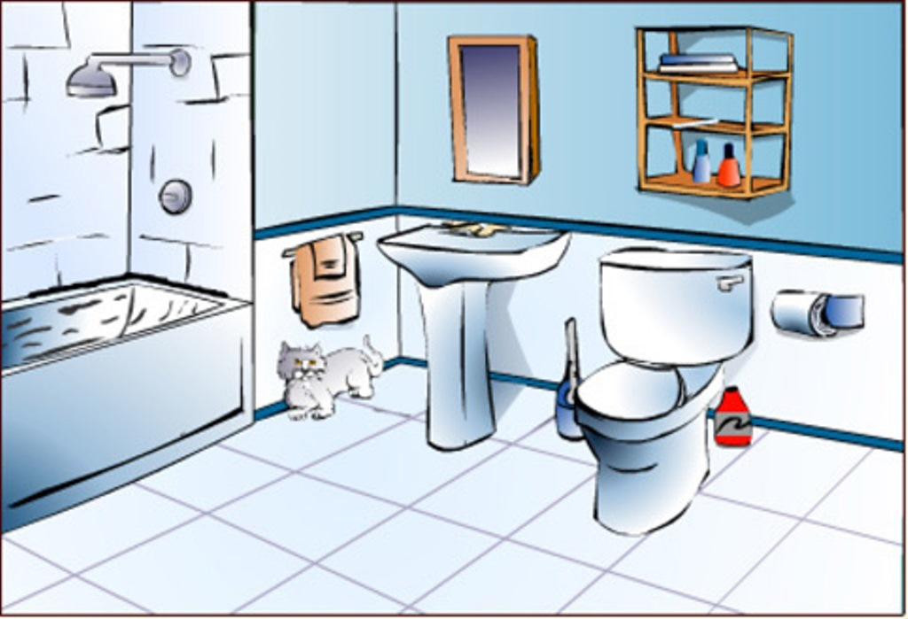

Personal Space/Privacy

Manager/CEO/ staff

Bedrooms
Personal Space/Privacy

- All bedrooms are single – unless a clinical justification indicates otherwise and the service user agrees to the arrangement.
- Windows have curtains.
- Staff will knock on the doors prior to entering.
- Visitors cannot enter service user’s bedrooms without their permission.
- Service users have access to their bedrooms at all times.
- Service users have the opportunity to store their possessions safely (examples: lock their bedroom door, have a lockable cabinet).
- Service users using mobility aids are able to move safely around their personal space/bed area.
- All bedrooms have windows that provide natural light.
Service users:
- Have a phone available in an area where calls can be made in privacy.
- Have access to meet visitors in an area where privacy is ensured.
- Have one-to one or meetings with service providers in privacy.
- Photographs/videos cannot be taken without the service user’s written permission.
- Photographs/videos cannot be published without the service user’s written permission.

Communal Areas
Personal Items
- Staff will not use any of the service user’s possessions such as mobile phones, cameras, radios etc.
- Staff will not remove service user’s possessions without discussing this with the service user.
- Service users are responsible for their possessions.

Are available for:
- dining
- recreation
- meditation/contemplation
- work
- sports
- sensory modulation

Ventilation and Heating

Manager/CEO

Heating
Ventilation

Room temperatures:
Types of heather

Ventilation guide
Tackling dampness

Building and Property Maintenance

All staff will be familiar with the location of the fuse box, water main and hot water cupboards.
Service users are provided with information how to access maintenance support.
Repairs

Urgent Repairs
Routine Maintenance

Manager/staff
Staff on duty/service users
Manager

- Staff will contact the …….. once the need for repairs are identified.
- The approved suppliers will be contacted to arrange the repairs being done.
- Is carried out according to the maintenance log.
- Inform the staff on duty.
- Staff on duty will contact the approved suppliers to arrange. repair.

Follow the Health and Safety processes if it is a health and safety issue

Approved Repair and Maintenance Services

Electrician
Name:
Contact:
Plumber 24/7
Name:
Contact:

Building Work/Painting
Name:
Contact:

Odd Jobs
Name:
Contact:

Fire Equipment
Name:
Contact:

Locksmith
Name:
Contact:

Glazing
Name:
Contact:

Power Supplier
Name:
Contact:

House Alarm
Name:
Contact:

Telecommunication
Name:
Contact:

Information Technology
Name:
Contact:

Consultation
Group/Role | Date

