Purpose | Our organisation is committed to the health and wellbeing of the people engaged with our service and the wider community by providing healthy eating and beverage options.
Scope | People receiving services, employees, visitors and people we provide or make food and drinks for.
Policy | The organisation provides an environment that supports healthy food and beverage options that support a balanced diet.  Providing a healthy eating environment is a health and safety issue that is supported by all levels of our organisation.
References
DHB agreements and variations of the agreements
Eating and activity guidelines
Eating and activity guidelines for New Zealand adults
Equally Well resources
https://www.heartfoundation.org.nz/wellbeing/healthy-eating/eating-for-a-healthy-heart
Healthy Eating Plate. Harvard University
Healthy food and drink policy for organisations
National healthy food and drink policy
Nutrition Safe Food & Fluid Management ( refer to continuum of service delivery)
Food and physical activity/guidance nutrition and physical activity workplaces.

Our organisation will consider the following to improve healthy food and drink environments:

- different cultures  - religious requirements  - special dietary needs | - Discourage association with products and brands that are inconsistent with a healthy food and drink culture. | Promote practices that are:  - ecologically sound  - sustainable  - socially responsible purchasing and use of food and drinks  - promoting the procurement of seasonal and locally grown and manufactured food and drinks.
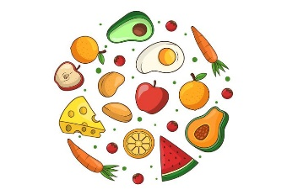 | 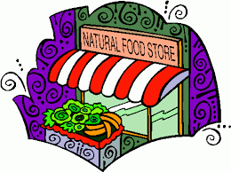 | 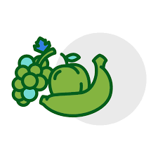

The following contexts are included in our commitment to healthy food and drink provision:

Food or drink provided by or able to be purchased from any  - retailer  - caterer  - vending machine  - snack box  - volunteer services  on the organisation’s premises for consumption. | Gifts, rewards and incentives offered to service users, staff, guest speakers and/or formal visitors on behalf of the organisation if containing food and/or drinks. | Fund raisers:  - where food and drinks are sold or intended for consumption on the premises  - associated with groups outside the organisation that do not meet this policy should not be promoted on the premises.

Our organisation offers a variety of healthy foods and drinks:

- plenty of vegetables and fruit  - grain foods, mostly wholegrain and those naturally high in fibre  - milk and milk products, mostly low and reduced fat  - legumes, nuts, seeds  - fish and other seafood  - eggs  - some poultry and/or red meat with the fat removed. | - some foods containing moderate amounts of saturated fat, salt and/or  added sugar may be available in small portions (eg, some baked or  frozen goods)  - no deep-fried foods  - no or limited confectionery (eg, sweets and chocolate). | - the availability and portion sizes of drinks containing ‘intense’  sweeteners and no-added-sugar juices are limited  - no sugar-sweetened drinks.
For guidance on how the principles could be implemented, refer to the National Healthy Food and Drink Policy (National Policy). The National Policy categorises foods and drinks, includes recommended portion sizes for some foods and provides examples of healthy options (refer to the healthy food and drink environments nutrient criteria table).

Our organisation promotes healthy options

- We display and provide consistently evidence-based nutrition messages. | - We do not partner with fundraisers, associations and promotions involving products and brands that are inconsistent with healthy food and drink principles.

We support healthy nutrition for employees and their babies

- We provide staff with reasonable access to food storage facilities such as fridges, lockers or cupboards.  - Wherever possible, this includes reasonable access to equipment to warm/ heat food. | - We provide access to drinking-water for all staff and visitors on site.  - We encourage staff to bring their own water bottle.  - We ensure that water coolers are replenished, clean and serviced on a regular basis.  - We consider environmentally friendly and recyclable options when purchasing cups for water dispensing. | We encourage and support mothers returning to work to continue breastfeeding by:  - Providing suitable areas that may be used for breastfeeding and for expressing and storing  breast milk.  - Providing suitable breaks for staff who wish to breastfeed during work, where this is reasonable and practicable.

The following situations are excluded from this policy/procedure:

Food and drink brought to work by staff for their own consumption. | Gifts to staff from clients or customers. | Self-catered staff-shared meals, both on and off site (eg, food brought for special occasions, off-site self-funded religious or other celebrations). | Gifts, rewards and incentives that are self-funded.

