Purpose | This document informs name of service practices to keep children accessing or being involved in the service provision safe. It aims that potential abuse and neglect, along with general concerns about child wellbeing, are identified and appropriately responded to.
Scope | - All employees, contractors, student placements and volunteers.  - All children that receive services and all parents or guardians who take care of children and are persons receiving services from name of service.  - This policy and procedure applies to housing and recovery services as well as to services that include home visits.  - All services of name of service.
Policy | - The safety and security of children is paramount.  - This document fulfils our organisation’s commitment to identifying and responding to child abuse and neglect and the vulnerability of children in a timely and appropriate way.  - name of service recognises that there is increasing awareness that abuse and neglect of children can and does happen and name of service determined to make a positive difference to this problem.  - We are committed to promote a culture where staff feel confident that they can constructively challenge poor practice or raise issues of concern without fear of reprisal.
References
Legislation | Children, Young Persons, and Their Families Act 1989.
 | Vulnerable Children (Requirements for Safety Checks of Children’s Workers) Regulations 2015
 | Vulnerable Children Act 2014
Guidelines | About the Vulnerable Children Act 2014
 | Children’s Action Plan
 | Children’s worker safety checking under the Vulnerable Children Act 2014
 | Safer organisations safer children
 | Ministry of Health NGO and Disability Network
 | Working together to keep children and young people safe
Definitions and Roles
Child | A child or young person aged under 17 years (who is not married or in a civil union).
Child protection | Activities carried out to ensure that children are safe in cases where there is suspected abuse or neglect or they are at risk of abuse or neglect.
Core children’s workers | Work alone with children, or have primary responsibility for, or control over, them. Examples of roles that may meet this definition are doctors, teachers, nurses, paediatricians, youth counsellors and social workers.
Child, Youth and Family | The agency responsible for investigating and responding to suspected abuse and neglect and for providing care and protection to children found to be in need
Designated person for child protection | The manager/supervisor or designated person responsible for providing advice and support to staff where they have a concern about an individual child or who want advice about child protection policy.
Disclosure | Information given to a staff member by a child, parent or caregiver or a third party in relation to abuse or neglect.
Non-core children’s workers | Are workers who have regular or overnight contact with children, without a parent or guardian being present. Examples of roles: social and health workers.

References cont.
New Zealand Police | the agency responsible for responding to situations where a child is in immediate danger and for working with Child, Youth and Family in child protection work and investigating cases of abuse or neglect where an offence may have occurred.
Vulnerable Children’s’ Hub | Is a contact point for frontline professionals and practitioners in some New Zealand communities to raise concerns about vulnerable children whose needs are not serious enough to contact Child, Youth and Family or the Police.

Types of Abuse and Neglect

Sexual Abuse
Physical Abuse
Contact Abuse
Any acts that involve forcing or enticing a child to take part in sexual activities,
whether or not they are aware of what is happening. Sexual abuse can be, but is not limited to:

Any acts that may result in physical harm of a child or young person. It can be, but is not limited to: bruising, cutting, hitting, beating, biting, burning, causing abrasions, strangulation, suffocation, drowning, poisoning and fabricated or induced illness.

Touching breasts, genital/anal fondling, masturbation, oral sex,
penetrative or non-
penetrative contact with the anus or genitals, encouraging the child to perform such acts on the perpetrator or another, involvement of the child in activities for the purposes of pornography or prostitution.

Emotional Abuse
Any act or omission that results in adverse or impaired psychological, social, intellectual and emotional functioning or development. This can include:
- Patterns of isolation, degradation, constant criticism or negative comparison to others.
- Isolating, corrupting, exploiting or terrorising.
- Exposure to family/whānau or intimate partner violence.

Non-contact Abuse

Exhibitionism, voyeurism, exposure to pornographic or sexual imagery, inappropriate photography or depictions of sexual or suggestive behaviours or comments.

Neglect
Neglect is the most common form of abuse and although the effects may not be as obvious as physical abuse, it is just as serious. Neglect can be:
- Physical (not providing the necessities of life like a warm place, food and clothing)
- Emotional (not providing comfort, attention and love)
- Neglectful supervision (leaving children without someone safe looking after them).
- Medical neglect (not taking care of health needs).
- Educational neglect (allowing chronic truancy, failure to enrol in education or inattention to education needs).

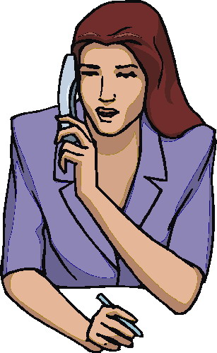

Signs of Potential Abuse

Emotional Abuse/Neglect

Physical Signs
Developmental Delays

Unexplained injuries, burns, fractures, unusual or excessive
itching, genital injuries, sexually transmitted diseases.
.

Small for their age, cognitive delays, falling behind in
school, poor speech and social skills.

Sleep problems, low self
-esteem, obsessive behaviour, inability to cope in social situations, sadness/loneliness and evidence of self-harm.

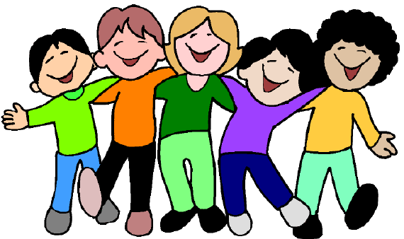
Disclosure
Behavioural Concerns

The child talking about things that indicate abuse (sometimes called an allegation or disclosure).
.

Age-inappropriate sexual interest or play, fear of a certain person or place, eating disorders/substance abuse, disengagement, neediness, aggression.

Signs of Potential Neglect

Emotional Abuse/Neglect

Physical Signs
Developmental Delays

Looking rough and uncared for, dirty, without appropriate
clothing, underweight.

Small for their age, cognitive delays, falling behind in school, poor speech and social skills.

Sleep problems, low self
esteem, obsessive behaviour, inability to cope in social situations, sadness/loneliness and evidence of self-harm.

Neglectful Supervision
Behavioural Concerns
Medical Neglect

Disengagement/neediness, eating disorders/substance misuse, aggression.

Out and about unsupervised, left alone, no safe home to return to.

Persistent nappy rash or skin disorders or other untreated medical conditions.

Factors to be considered

- Each situation is different.
- Consider all available information about the child and their environment before reaching conclusions.

DHB child teams that can be contacted for advice and support.
ADHB
Counties Manukau DHB
Waitemata DHB
Northland DHB
Child Youth and Family:
If you are worried about a child

Reporting Process for Child Abuse
You !!!!

Are told by a child that she/he is being abused
Observe signs of abuse in a child
Observe a child being abused
Respond to the child’s needs

At this stage do not share any information with other staff members or the person(s) being accused of the abuse or neglect.
If your manager is the suspected abuser inform the chairperson of the Board or the owner/director of the organisation.

Prepare a written record:

- Date, time and place of observation/reporting of abuse/observations.
- Names of anyone present.
- What the child says – exactly.
- Any physical or behavioural sings of abuse.
GIVE THE RECORD TO THE MANAGER OR CHAIR OF THE BOARD OR OWNER OF THE ORGANISATION.
Person in Charge

Person in Charge

Confidentiality of Information

Workforce Development

Worker Safety Checks
Board/Director/Employer

Possible risk assessment queries
- Has officially recorded name changed?
- Update information with professional body.
- Do police vetting.
- Assess work behaviours.
- Check complaints/incidents.
- Evaluate the information obtained.
- Conduct a risk assessment.
- Decision to continue working with children will be informed by Schedule 2 of the Vulnerable Children Act 2014
- Confirm identity.
- Take a work history.
- Reference check.
- Interview the job applicant.
- Do police vetting.
- Check with the professional body about any concerns.
- Evaluate the information obtained.
- Conduct a risk assessment.
- Decision to hire will be informed by Schedule 2 of the Vulnerable Children Act 2014

First check/recruitment
3-yearly check
Core work force:
By 1st July 2015
Non - core work force:
By 1st July 2016
This process applies to new recruitments and the existing workforce.
Persons to be safety checked:
Safety checks
Employers are accountable for ensuring safety checks are done. Others can complete checking for them on their behalf but the accountability will always lie with employers.

Board/Director/Employer completes the Safety Checking Employer Endorsement

Students on placement
Volunteers
Contractors
Employees

Consultation

This document needs to be signed off by the Manager/CEO

Name or group | Date | Evidence

