Purpose | Service user’s individual food, fluids and nutritional needs are met by name of service where this is a component of service delivery.
Policy | Management of food will be in line with current legislation and guidelines. name of service will only provide safe and suitable food.
Scope | All service users, staff and premises.
References
Legislation | Food Act 2014  Animal Products Act 1999  Auckland City Council Food Safety Bylaw 2016
Standards | NZS 8134: 2008 Health and Disability Services Standards (HDSS)
Guidelines and information | Auckland City Council: Food Safety  Diabetes NZ  Food control plans  Food and nutrition guidelines for older people  Healthnavigator  Heart Foundation Food and nutrition guidelines  MOH Food and nutrition guidelines  Ministry of Primary Industry website  Marae food safety guide  Safe and suitable food video
name of service policies and procedures | Infection prevention and control management  Service delivery pathways
The Food Act 2014 specifies the requirements for services that prepare food. You
‘Where do I fit?’

Consider:
- What does your service agreement/contract require? Do you need to provide food for the service users who receive services from you?
- Who is cooking the food? Service users cook only food for themselves? They cook with others? They cook with staff?
- Do service users manage their food? Buying, cooking, storing?
- You need to have HealthCert certification? Including the Nutrition and Food Standard 1.3.13?
- What is your duty of care obligation in terms of food provision?

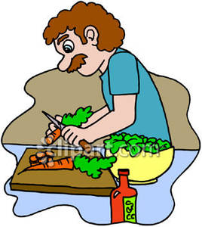
Below are examples of tier three service specifications that may require a food control plan.
Services manage food and nutrition in various ways, even though they have the same tier three service specification. If your service has employees that buy, store and cook food for or with service users then the requirements apply to your service:
Service provided | Service User Numbers | Requirements
Any Day Programme you do food catering for the participants.  (if participants bring their own food you do not require a food control plan) | Less than 10 participants. | Adhere to food safety guidelines
 | Over 10 participants. | Food control plan – Getting started with your food control plan.  Apply by 31 March 2018.
Any Day Programme a caterer delivers food for the participants. | Over 10 participants. | You need to check that the caterer is registered.
- Housing and recovery service  - Community Co-existing Disorders, Mental Health and Addiction Service, (with accommodation)  - Child, Adolescent, and Youth - Community Alcohol and Drug Services (with accommodation component)  - Child, Adolescent and Youth Mental Health Community Care with accommodation component  - Child, Adolescent and Youth Planned Respite for Mental Health and Alcohol and Other Drug Co-existing Disorders  - Health Infant, Child, Adolescent and Youth - Crisis Respite  - Older People Services - Sub-Acute/ Extended Care Service  - Alcohol and Other Drug Services - Community Support Service with Accommodation  - Intensive Alcohol and Other Drug Service with Accommodation  - Specialist Eating Disorders Service (with accommodation)  - Perinatal Community Mental Health Service (with Accommodation)  - Respite Services | Less than 10 service users per residence. | Adhere to food safety guidelines
 | Over 10 service users per residence. | Food control plan – Getting started with your food control plan.  Apply by 31 March 2018.  The Act doesn’t apply to residential and/or home care where residents prepare meals or have help preparing meals.
If you have reason to think that your service should be exempt from developing a food control plan, you can apply using this link: https://www.mpi.govt.nz/food-safety/food-act-2014/overview/exemptions-from-plans-or-programmes/
Services that are established from March 2016 on will need to implement the required processes before they become operational.
Watch the videos on the Ministry of Primary Industry website!!!!!!!!!

Examples
Service provided | Service User Numbers | Requirements
You employ a cook who prepares food on a daily basis for all service users. | 10 or more  (capacity) | Food control plan and registration.  HealthCert requires that the cook has a food safety certificate.
Your cook works only on weekdays and support staff or clients cook on weekends and public holidays. | 10 or more  (capacity) | Food control plan and registration.  HealthCert requires that the cook and the staff involved in cooking have a food safety certificate.
Your support staff cooks for all service users and the service users help with cooking. | 10 or more  (capacity) | Food control plan and registration.  HealthCert requires that staff involved in cooking have a food safety certificate.
Depending on the needs and ability of the service users sometimes support staff cook for all clients and sometimes they cook for less than ten service users. | 10 or more  (capacity) | Food control plan and registration.  HealthCert requires that staff involved in cooking have a food safety certificate.
Service users have their own food budget and cook only food for themselves. Support workers provide oversight and support for the individual service users to learn to buy and prepare food. | 10 or more  (capacity) | Adhere to food safety guidelines.  HealthCert requires that staff involved in cooking have a food safety certificate.
Service users have their own food budget and cook only food for themselves. The situation is like a flatting situation where service users share a kitchen, but cook only for themselves. | 10 or more  (capacity) | Adhere to food safety guidelines.
You buy all meals from a caterer. | 10 or more  (capacity) | Ensure that the caterer is registered.
Your arrangements are a combination of getting food from a caterer and staff preparing food. | 10 or more  (capacity) | Food control plan and registration.  HealthCert requires that staff involved in cooking have a food safety certificate.

Processes for food management
If you cater for older or vulnerable service users you need to use a custom FCP

Food Control Plan (FCP)

Develop your plan using the guide on the Ministry of Primary Industry website.
Day programmes and/or housing and recovery services doing food catering for 10 and more people.
A written plan to help with the day to day management of risk related to food management.

Residence(s) in one
Council area
Multiple residences in different Council areas

Request a registration form from your council
The plan needs to be evaluated by an independent evaluator.

Complete:
Your registration form.
Any other requirements as stipulated by the council.
Your scope of operations form.

Before you register you need a verifier to confirm in writing that they agree to audit your system.

Return all forms to your local council
Register

Send:
Your food control plan.
Your application.
Your scope of operations form.
Your site plans for every address you operate from (10 or more service users)
To
approvals@mpi.govt.nz

Verify

An environmental health officer from your council – will visit to check your plan, to ensure you are following it to make safe food
&
verify you.

Verify
Verification will need to be maintained.

The independent verifier you chose before you registered will do the verification.

Keep your plan current.

Verification will need to be maintained.

Keep your plan current.

Provision of service user’s food, fluid and nutritional needs
Throughout service delivery

Service user, their family/whānau and service provider

Respond to individual service user’s nutrition requirements by considering:

Assess individual service user’s nutrition requirements by considering:
General dietary requirements:
- MOH Food and Nutrition Guidelines page
- food and nutrition guidelines for healthy adults
- Guidelines for older people
- Guidelines for healthy children and young people
- food for health brochure
- healthy food guide

- Identifying the need to engage a specialist (dietician, diabetes nurse)

- assists in monitoring the service user’s weight
- assists the service user to have metabolic screening

Specific dietary requirements (examples):
- keeping well with diabetes
- eating gluten free
- lactose intolerance
- vegetarian
- vegan
- macrobiotic
- kosher
- halal

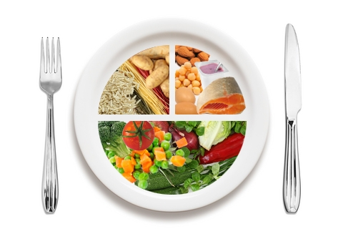

Access to food and fluid
Meal preparation
(Refer to infection prevention and control manual/plan)

- Service users requiring specific modified eating/drinking equipment/aids will be provided with what they need.
- Provision of nutritional information to service users and their family/ whānau.
- Service users have free access to fluid and food as they require.
- Service users to make informed choices about their nutritional intake.
- The service will not provide drinks that contain unreasonable amounts of sugar.
- If collecting food, consider any Rāhui
placed in the area.
- Consider service users’ and their families/whānau Tikanga.
- The service will provide cholesterol lowering food.

Consultation
Group/Role | Date

