Purpose | To collaboratively identify and manage safety and risk issues in order to provide the safest possible recovery and treatment context for clients, their family/whānau/carers and the wider community.
Scope | The organisations’ employees and other relevant service providers.  Contracts/agreements that include ‘assessment’ in the Tier 3 ‘Service Component Processes’ are required to identify and manage service user’s safety/risks (in line with their overall service delivery model).
Principles | Our service will:  - Move towards recovery-oriented risk assessment and safety planning.  - Base the process on shared decision making and the joint construction of personal safety plans.  - Use an approach that respects service users’ needs, while recognising everyone’s responsibilities – service users, professionals, family, friends – to behave in ways which will uphold and maintain personal and public safety.  - Acknowledges that overdefensive, risk-avoidant practice is bad practice and is associated with avoidable harms to both the people who use services and to practitioners.  (Jed Boardman and Glen Roberts: Risk, Safety and Recovery (June 2014).
Policy | Services will receive risk management documentation and instruction from clinical providers that need to be considered.  The service will implement the current emerging approach to recovery oriented safety and risk planning.
References
Guidelines  &  Resources | Best practice in managing risk: the assessment and management of risk to self and others in mental health services (UK Department of Health) 2009  Rethinking risk to others in mental health services (Royal College of Psychiatrists) 2008.  - Risk, Safety and Recovery (Jed Boardman and Glenn Roberts) 2014.  - Suicide prevention, MOH  - Suicide prevention, Health Navigator 2017.
Definitions
Vulnerability to safety/risk factors | Some pattern of behaviour over time, current environment or mental state that makes it likely that an unsafe or risky event occurs.
Static factors | Those circumstances that do not change, for example ethnicity, or that change slowly such as age including historical risk events.  Note: the majority of static factors in practices include gender. This service does not accept that this is a static factor.
Dynamic factors | Circumstances that change and can be influenced. There are two subgroups:
 | Internal dynamic | Situational dynamic
 | Those are directly related to a person’s mood or mental health state. Those factors can act as triggers and need to be identified when developing early warning signs. | They are related to specific situation and the environment and are acting as triggers.
Protective factors/ resilience | Specific resources, learnings, behaviours, responses, environments, relationships that the individual person can draw on to reduce the likelihood that safety is compromised.
Risk formulation | A narrative that tells a coherent, ordered and meaningful story about underlying mechanisms of risk. The story proposes a hypothesis regarding action for change.

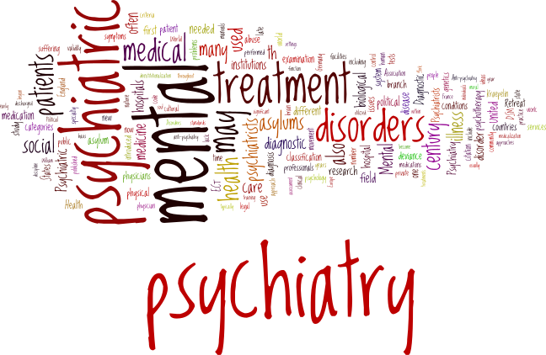
“We must differentiate between risks that must be minimised and risks that people have a right to experience”. (Royal College of Psychiatrists, 2009).

Key elements of person (service user) -centered safety planning

Key participants of person (service user) -centred safety planning

Considered are the views of safety, dangers and concerns by:

Shared responsibility for safety.
Listen to the views and concerns.

Factors to consider when assessing and discussing risk and safety issues:
- Safety assessment and plan are based on ‘person-centred safety planning’.
Mental State | - behaviour  - affect  - cognition  - perception  - resilience  - anxiety  - vulnerability | Medical | - injuries  - alcohol or other drug withdrawal  - allergies  - hypersensitivities  - medicine adverse effects  - sensory issues
Environment | - immediate stressors  - access to weapons, drugs  - discrimination  - relationships  - compulsory treatment  - environmental restraint | Historical Information | - illness and incidents  - family background  - trauma
Cultural considerations | - Acknowledgement of different concepts of safety.  - Language barriers.  - Reluctance to disclose, or shame and fear of disclosure.  - Tolerance of risk.  - Acknowledgement of different ways of managing safety issues.  - Involvement of family/whānau/iwi/fono/in risk management  - Involvement of tohunga/ kaumatua/spiritual guide/matua.
Consider the principles of tapu and noa.

Consider the following areas for discussion with the key participants

Continuum of safety issues

High
Moderate
Low

- The absence of substantial safety/risk factors.
- There is no imminent risk to the service user or others.
- The service user experiences no significant social/occupational difficulties
- The service user has a supportive social network.
- The service user has positive experiences
with recovery processes.

- Current self-harm or harm to others behaviour.
- Inability to manage aspects of daily living activities safely.
- Unmanageable medical condition.
- Lack of emotional and material support.
- Living in a hostile environment.
- Social isolation.
- Inability of service providers to provide effective support and interventions.
- Current wish to self-harm or harm others without a concrete plan.
- Current disabling distress.
- Moderate difficulty in social or occupational performance.
- The service user has a limited social network.
- The service user is alienated from family, friends and supports.
- The service user has a medical condition requiring close monitoring.
- Service providers have not managed to offer effective support

Identifying safety and risk issues

At referral/service entry
All described processes
Service user/referrer/staff

- Referral information includes safety and risk issues.
- Referrer has a plan in place for service users with safety/risk issues.

Possible Participants:

- relevant service providers
- family/whānau
- cultural support
- advocate
- peer support
Assessment/exploration

Within ……….days of service entry
Service user/role of staff member

- Review the safety/risk issues identified at referral/service entry.
- Amend the safety/risk issues if required.
- Develop a recovery oriented safety plan.
- Keep a copy of the plan.

Risk/safety information might be shared with:

- clinicians involved in service user’s care
Consider:
- family/whānau
- carer
- other service providers
- statuary reporting requirements
- any person the service user stipulates

Reviews
At least 3 monthly and as required

Service user/role of staff member

- Safety issues are discussed.
- The safety plan is amended as required based on the discussion.
Examples of additional reviews:
- Daily during a crisis.
- The service user requests a safety discussion.
- After adverse events.
- During situational changes.
- Declining in wellbeing.
- Change in treatment/support setting.
- Change in level of contact.
- At request of family or support people.

Discharge/transfer

Within …..days of the discharge/transfer
Service user/role of staff member

- Discharge/transfer support includes the identification of safety and risk issues.
- A safety plan is place and discussed before the discharge process commences.

Consultation
Group/Role | Date

